

217, Sheikh Rashid Building

P.O Box 56272, Dubai

United Arab Emirates

Tel: +971 4 2973236 / 04 2974007

Email: uae@verbat.com

PROJECT   
PROPOSAL

**Website Redesign of www.goldmark.ae**

|  |  |
| --- | --- |
| **Prepared for:**  **Goldmark**  **Joaquim Philip D’Almeida**  Asst. Manager Procurement  Tel: +971 2 5509570 Mob: +971 50 7921581  Email: joaquim@penta-global.com | **Submission Date:**  07th February 2017  **Proposal ID:** SW/12122016/1245/1 |

___________________________________________________________________________________________________________________________________________  
Conﬁdentiality Notice: This Proposal is conﬁdential and contains proprietary information and intellectual property of Verbanet Technologies LLC. Neither this proposal nor any of the information contained herein may be reproduced or disclosed under any circumstances without the express written permission of Verbanet.

© 2017 by Verbanet Technologies LLC. All rights reserved. Confidential.

___________________________________________________________________________________________________________________________________________

Project Contacts

|  |  |
| --- | --- |
| Client Information | |
| Project Name | Website Re-design of www.penta-global.com |
| Client Name | Penta Global Engg Co LLC |
| Client Address | Plot No. 47NR27, ICAD III PO BOX 8276, Mussafah,  Abu Dhabi, U.A.E |
| Phone Number | +971 2 5509570 |
| Contact Person | Joaquim Philip D’Almeida  Asst. Manager Procurement |
| Contact Person Email | joaquim@penta-global.com |
| Contact Person Phone Number | +971 50 7921581 |
| Contact Person Fax Number | +971 2 5509571 |
| Verbat Information | |
| Contact Person | Joyce Daniel |
| Contact Person Phone Number | +971 4 2973236 |
| Contact Person E-Mail | Joyce.daniel@verbat.com |
| Address | PO Box 56272, Dubai |
| Physical Address | Flat 217, Sheik Rasheed Building, Hor Al Anz East, Dubai |
| Project Information | |
| Proposed Technology/Methodology | PHP, code ignitor |
| Anticipate Start Date | NA |
| Proposal Valid For | 30 Calendar days from the submission of the proposal |

**Table of Content**

1 Introduction 5

1.1 Project Overview 5

1.2 Why Verbat 7

1.3 Key Differentiators 8

1.4 Underlying Support Services 9

2 Scope of work 10

2.1 Web Design and Development 10

2.2 SEO 11

3 Technology Solution 12

3.1.1 Web site Design 12

3.1.2 Web Hosting 12

3.1.3 Browser Compatibility 13

4 Assumptions 14

5 Out of Scope 14

6 Delivery Management 15

6.1 Project Management 15

6.2 Roles and Responsibilities 15

6.3 Phase Delivery Activity summary 16

6.4 Project Implementation plan 16

6.5 Deliverables 16

6.6 Deployment Details 17

6.7 Release Planning 17

6.8 Risk and Contingency planning 17

7 Change Management 19

8 Project Effort & Timeline 20

8.1 Effort 20

8.1.1 Web Redesign and Development 20

9 Commercial 20

10 Miscellaneous 21

10.1 Acceptance Criteria 21

10.2 General Terms and Conditions 21

10.3 Assumptions and Dependencies 21

11 Our Clients 23

# Introduction

**Thank you for the opportunity to submit this proposal for the redesign of the goldmark.ae.**

Gold Mark (Here after referred to as the client) Real Estate formed in late 2015 brings together a collective experience of over 30 years in Real Estate markets across the Middle East and United Kingdom. The aim is very simple: to create an honest, stable, energetic platform for our high performing professional staff who in turn will be well equipped to cater for all new and existing clients. The client has requested Verbat to redesign their website in order to promote their business and grow their target audience. The main objectives of the application is for:

* Creating a more professional web presence for GoldMark through the use of elegant designs and a highly useable interface
* Providing easy channels for interested parties to connect with GoldMArk staff and other readers
* Utilizing a Responsive, scalable, modular web platform that will allow future functionality to be seamlessly integrated as GoldMark continues to grow and expand
* Leveraging social networking features to reach a broader audience and engage readers more deeply
* Verbat Technologies is uniquely qualified to help redesign Goldmark website, due to our:
  + Expert consulting, creative and development staffs
  + Vast experience in Web development and web design
  + Proven record of executing strategic, high-level projects for large, diverse and dispersed audiences.

## Project Overview

Verbat Technologies is a team of Digital Technology experts including consultants, web developers, graphic designers, programmers, marketing and SEO experts. Our specialty is creating modern, interactive, responsive, SEO ready websites. **The project is to re-design the website, including:**

* Re-design the existing website and all the required features
* Re-Designing the website with a responsive design so that it looks good on tablets and desktop or laptops
* Make the website “ready” for search engines for relevant keywords

Our web design process starts with the creation of a detailed requirement document followed by Prototype of the website, to ensure that we understand your exact requirements and finishes with hosting in a secure environment, to give you peace of mind.

## Why Verbat

Globally Accredited

Software Consultation Partner

Spearheaded by a   
team of Technology and   
Management Leaders



Over 16+ years of customer experience with Global   
Corporations

Service in Banking, Retail, Logistics, Construction & Contracting, Fashion, Manufacturing, Hospitality, Automotive, Healthcare and Government sectors

IT Strategy, Application Development and Maintenance, Testing Services, Information Management and Digital Marketing efforts



## Key Differentiators

Delivered digital transformation expertise to global customers for over a decade by following industry best practices to maximize ROI for client

Keen technology intelligence combined with aggressive market research to deliver solutions that achieve results with measurable value

Enable access to global consulting expertise with strong local market and business knowledge

Commercial Model that is customizable for your business needs

Reuse of code libraries for Rapid Application Development

1,000,000 plus man-hours of expertise in technology frameworks spanning Microsoft, Open Source, mobility platforms and other proprietary IT technology

Partners top technology vendors to bring in the latest and best services in integration, collaboration, and development

Commercial Model that is customizable for your business needs

Proven Methodologies & Processes

Investment in R & D

Strong Local Presence

Flexible commercial Models

Technology Associations

Code Repository

Software Development Experience

Offshore Development Centre

## Underlying Support Services

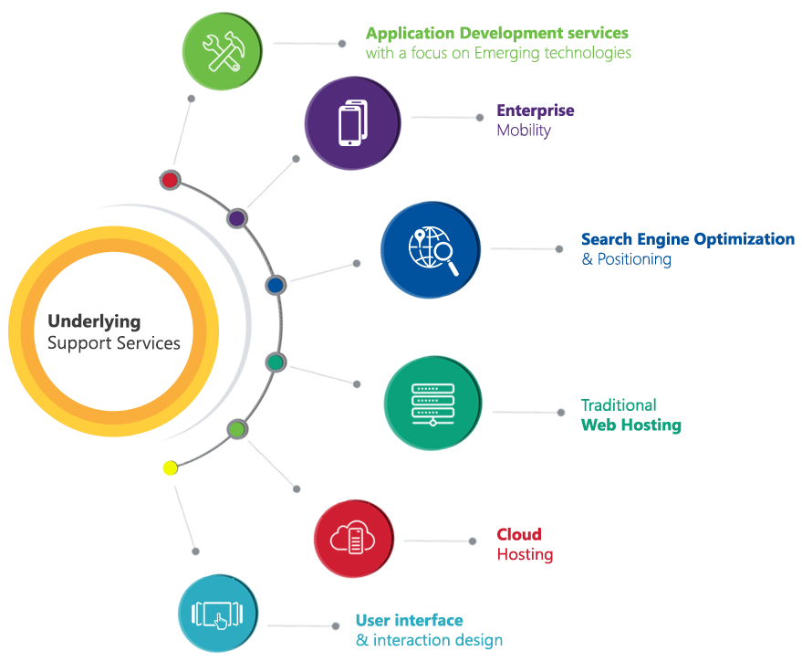

# Scope of work

## Web Design and Development

|  |
| --- |
| **Common** |
| Login, Forgot Password, Reset Password |
| Change Password |
| **Admin** |
| Manage Properies Sell, Buy |
| Manage Communities |
| Our Team |
| Manage master Data |
| Manage Content |
| Manage Newsletters |
| Manage Testmonials |
| **Client** |
| Home |
| Search (Buy, Rent & Sell) |
| Hot Properties (For Rent & Sell ) |
| Testimonial |
| Video |
| News |
| Channel Partner |
| Banner |
| Newsletter (Don't miss out) |
| Search Result |
| Advanced Search (Buy & Rent) |
| Property Listing with pagination & Sort |
| Property Details |
| Property Details (Aminities, images, details) |
| Agent Info |
| Member Details |
| Member Details (Aminities, images, details) |
| Agent Info |
| Meet Our Team |
| Careers |
| Communities |
| Contact US |

## SEO

# Technology Solution

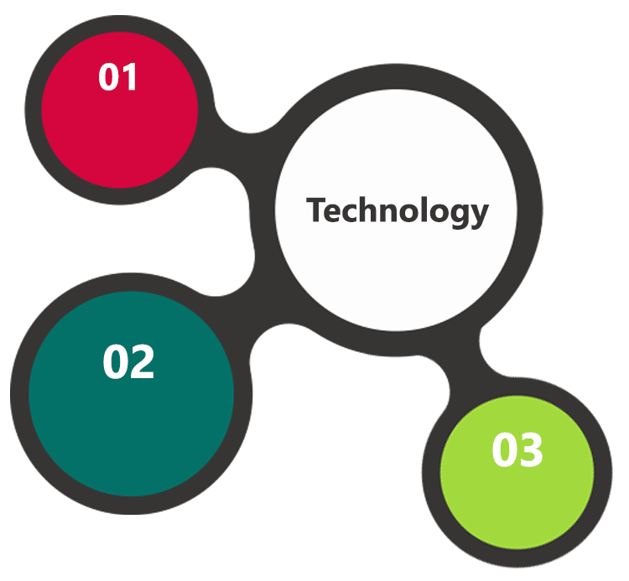

PHP

CodeIgnitor

CentOS  
Apache  
MySQL DB

HTML 5  
JavaScript  
CSS 3

### Web site Design

* Development environment and specification of the project
* Keeping the requirements into consideration, Verbat proposes a CMS based website using PHP & CodeIgnitor
* MySQL Server as the Database, CentOS as the server operating system
* Apache as the Web Server

### Web Hosting

We have our own servers with a couple of different hosts who have data centers in America and can

* Guarantee 99.9% uptime.
* Have strong security features
* Provide detailed visitor statistics.
* Respond quickly to support requests.
* Overall, this gives you peace of mind that your website is in good hands.

### Browser Compatibility

* Chrome version: 56
* Firefox version: 51
* Edge version: 39

# Assumptions

The project solution and technology is created from the initial understanding of the requirement shared with Verbat through mails and meetings. The proposed solution is based on the following assumptions;

* The website will have English language only
* Branding of the website shall be provided by the client
* Website content shall be provided by client in word format
* Client shall provide licensed images and logos in specified size & format
* HTML Template to be purchased by the client
* There shall be no client side login and registration
* Admin User will be the only role created
* There shall be no role based permissions

# Out of Scope

Following are considered to be out of scope while creating this proposal.

* Purchase of images, fonts
* Adding new features to the application other than mentioned in this proposal
* Any language other than English
* Physical deployment at client’s site
* Integration with any other systems other than those specified in the Scope
* Backup solution and Disaster recovery for web hosting
* Content writing
* Annual Maintenance Contract
* User manual & Test cases
* Data migration

# Delivery Management

## Project Management

The Verbat development center strictly follows industry standards on quality. The project management is process governed by the Verbat Quality Management system and is put to verification through internal audit programs that happen from time to time.

Verbat will dedicate a project leader for the proposed implementation. Verbat proposes Client to identify one project manager who will be driving activities to be undertaken by Client to be the single point of contact for Verbat.

## Roles and Responsibilities

Verbat will assign a dedicated Project Lead to lead the project, who will be the first point contact for Client. He/she will be responsible for planning and managing the various activities within the project. He/she will work closely with Client Project Manager, to give periodic status updates and ensure high level of visibility and comfort on the progress of the project.

The Project Lead will lead the co-ordination between Verbat and Client, thus enabling smooth transitioning of Client requirements to the Verbat’s offshore delivery team, and provide visibility as well as comfort on the progress of the services to Client.

He/she will have periodic meetings with Verbat’s Senior Management, thus ensuring Verbat’s Management commitment and focus on Client initiatives.

## Phase Delivery Activity summary

|  |  |
| --- | --- |
| Activities | Description |
| Detailed requirement Analysis | Verbat team to conduct detailed study of requirement for the phase. If clarification is required, team will reach out to Client for more information and/or time for discussions. |
| Requirement Specification document | Once the requirement analysis is completed, Verbat team will submit the Requirement document for approval |
| UI/UX Design, Prototyping | Purchase of the theme & based on the requirement document, Verbat UX/UI team will work on the prototype for approval |
| Development | Actual web design development starts based on the Requirement Document/Prototyping |
| Testing | Test Planning, test plan creations, internal, integration testing and user acceptance testing. |
| Deployment | Deploying the latest built in the Verbat Test Server. |

## Project Implementation plan

Verbat will be providing the solution in a phased approach which ensures minimum viable solution for quick wins with core focus on the long term business objective and outcome. Once the implementation of phase 1 is over, Verbat will initiate the application maintenance process which continues to extend after the implementation of successive phases.

## Deliverables

* Requirement Specification Document
* Wire Frames for Key Screens
* Prototype of website
* Fully Tested & Developed Website

## Deployment Details

* Client can opt for hosting the web site at Verbat’s Server
* If deployment is at the client’s server, responsibility of deploying the delivered built or any other interim releases onto the production environment after conducting the necessary acceptance testing will lie with the client unless and until Verbat’s support is contracted for deployment.

*Note: Hosting the application at Verbat’s server will call in for additional charges.*

## Release Planning

* Client will be informed about the release date and time through email.
* Client performs the User acceptance testing (UAT)

## Risk and Contingency planning

Verbat has identified various risk factors associated with this assignment and understands the impact of these risk factors on the project schedules. The objective of this section is to highlight for both Verbat and client, the risk factors, to analyse the impact of the risks on project execution, and to propose strategies to control and reduce the impact of the risk factors.

These various risks, which could arise during the project, are tabulated below along with mitigation implementation.

| Type of risk | Impact | Risk Mitigation | Risk Handling |
| --- | --- | --- | --- |
| Scope Creep | H | Functions and features will be detailed in system requirement documents and will go through client approval. Once this document is approved, any change to requirement will go through change management review for possible impact assessment. | Proper change management procedure will be implemented. |
| Delay in customer feedback | H | The plan is prepared with enough lead-time for customer reviews and approvals.  The customer is indicated with the dates when the document is expected after review and approval. | The request for feedback will be escalated if not attended at the right time so that the schedules are not affected. Deemed acceptance criterion is set up front and will be followed. |
| Non-availability of necessary software’s, frameworks, database instances and infrastructure at client’s hosting environment(If hosting support is provided by Verbat) | M | Client will be informed in advance on these requirements. | Possible impact to schedule. |
| Manpower attrition | L | All efforts would be made to ensure process dependence rather than being person dependent. As a risk mitigation plan Verbat will train backups. | A new person will be identified as early as possible, provided the required project-specific training and mentored by the senior members of the team to minimise impact of attrition on the project. |

*H-High, M-Medium, L-Low, NA-Not Applicable*

# Change Management

Any addition which comes out of the project scope, upon and after the launch of the tool will be considered as change management. Verbat recommends the following change management procedure for the same.

* Any change which comes out of the project scope, which was discussed, documented, and mutually approved by both the parties in the requirement stage, will be carried out only through raising a change request.
* Change request will be studied and an impact analysis on the existing work flow will be performed.
* On finalizing the impact, effort estimation for the change will be calculated and raised as additional requirement.
* Verbat will initiate the change request only after getting a formal approval from the client for the additional changes raised.
* Any change from the scope will be charged at **AED 1200 per man day effort** and approval from the clients will be availed before commencing on any change management.

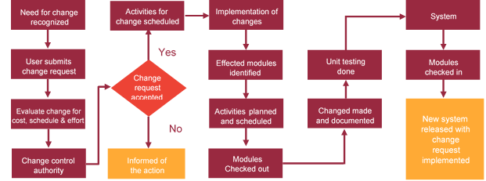

# Project Effort & Timeline

## Effort

### Web Redesign and Development

The effort estimated for delivering the re-designed web site shall be **35 working man days**

|  |  |
| --- | --- |
| **Activity** | **Effort (Man Days)** |
| System Study, Documentation and Project Management | 5.5 |
| Design & Prototyping | 08 |
| Development and Production | 21 |
| QA, UAT & Launch | 11 |
| **Total** | **46** |

# Commercial

|  |  |
| --- | --- |
| **Description** | **Cost (AED)** |
| Re-Design of the website www.GoldMark.ae | XX,XXX.00 |
| SEO for www.GoldMark.ae | XX,XXX.00 |

# Miscellaneous

## Acceptance Criteria

* UAT sign off should happen within 14 Days from the release of each module/ Phase and the acceptance confirmation needs to be mailed to Verbat failing which Verbat will consider the project as approved by the client.
* Any comments or reason for rejection need to be documented and the same needs to be sent as an email from the official mail id of client to Verbat.

## General Terms and Conditions

* Offer Valid for 30 calendar days from the date of submission of the Proposal
* An average of 20 working days are assumed in a month
* This proposal and all technical/ functional specifications have been derived or concluded from the data shared via email / information's transferred during the initial requirement analysis meetings and conversations. Verbat reserves the right to amend the terms of this proposal, should the SOW terms, functional features and functionalities change during the course of the project
* The applications will be built as per the specifications agreed mutually. Any changes will be executed through a deﬁned change management process between both parties
* All Source Code and other project artefacts would adhere to the Verbat document templates and internal coding standards
* Acceptance criteria shall be based on the clauses which were mutually discussed between Verbat and client at the Requirement Analysis phase and the same will be documented and approved by both parties through official emails
* Final deployment to production server pursuant to completion of all payments

## Assumptions and Dependencies

* During the requirement gathering phase, authorized personnel from the Client’s side is expected to be available for discussion and finalizing the HLD (High Level Design), before development commences.
* All queries regarding the client requirement and any queries which may hinder the project advancement at any stage should be answered by the client within 24 hours from the time of initiation, failing which the time delay will get added to the actual effort which was estimated.
* Verbat assumes that all sign-offs from Client will be provided within agreed and specified timeframe.
* Client will provide all the necessary contents, both text and image, before starting the project in the format suggested by Verbat (if any).
* The client should provide the relevant information and data well in time for the execution of a related activity. Non- availability of this information or data may lead to an interruption of work which may result in a delay in delivery as well as additional costs to the client.
* Data Migration has not been considered in the effort
* The estimation does not include User Manual & Test Cases

# Our Clients

**Sharjah Customs**

**UAE University**

Education

Transportation

**Canada Cartage**

Construction

Services

Logistics

We look forward to hearing from you soon and hope that you will give us the privilege to work with you in meeting your business goals. Thank you.

Thank You



©   
1999 - 2017. All Rights Reserved   
Verbanet Technologies LLC  
www.verbat.com